For reference on your own computer, here are the steps to write / compile / run a program using a simple text editor and the Command Prompt(PC) or Terminal (Mac):

1. To create your source code file without using any type development environment software, open a simple text editor such as Notepad / Notepad++ (PC) or TextEdit / TextWrangler (Mac), and type the code. When finished entering code, save your file with the same name as your Java class and with a **.java** extension.

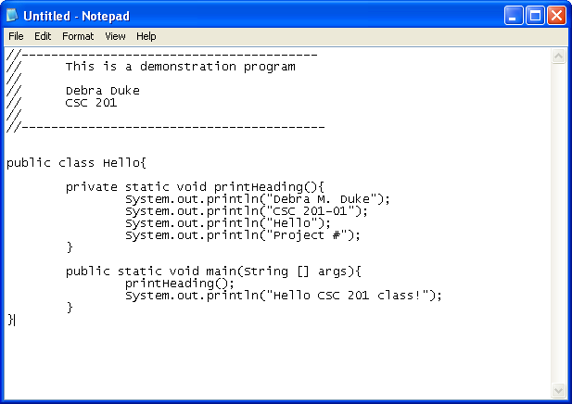

1. To compile your program, open the a Command Prompt window by selecting **start > Run..** and type in **cmd.exe**.

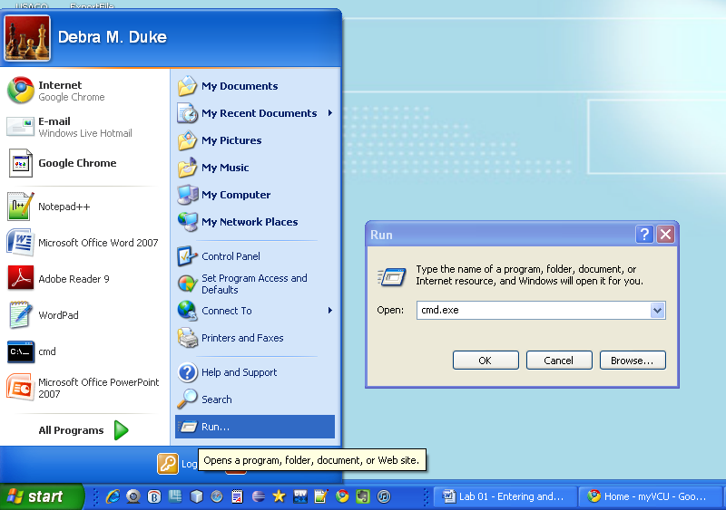

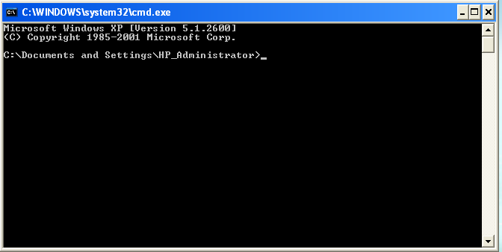

Use the dos command, **cd**, to change folders, and navigate to the directory that contains your source code file. (You can find a handy listing of some basic dos commands at this site, <http://www.cs.unca.edu/~jkdawg/help/msdos.html>)

1. Use the command **javac** followed by a space and then the name of your source code file (including the extension) to invoke the Java compiler that converts your source code into Java bytecode. For example, **javac Hello.java**
2. If there are no compiler errors you can run the program with the command **java** followed by a space and the name of your program without the extension. For example, **java Hello**

This command uses the Java Virtual Machine to interpret your bytecode file and execute the resulting machine code. Output created with System.out statements will be visible in the command prompt window.